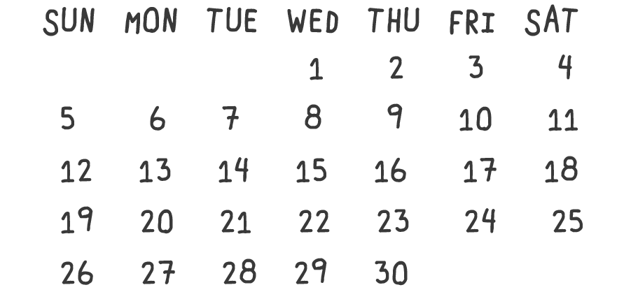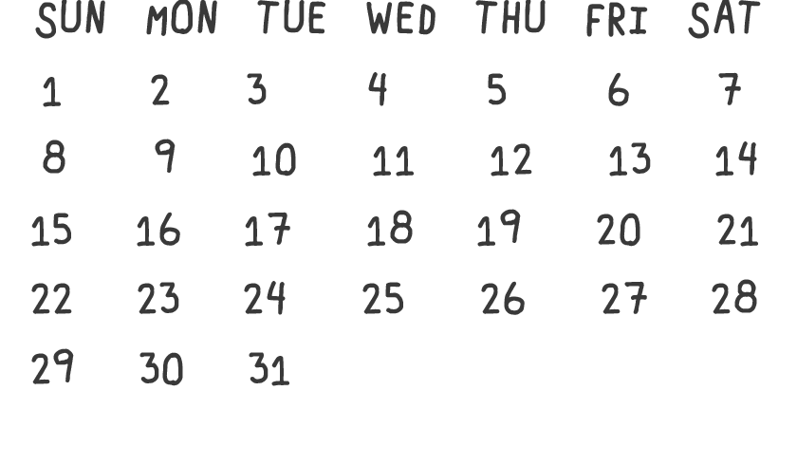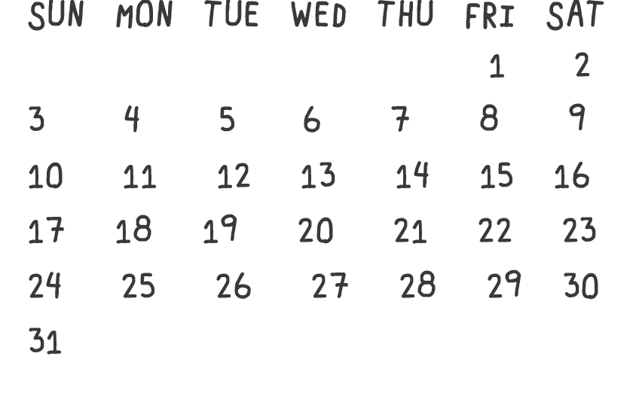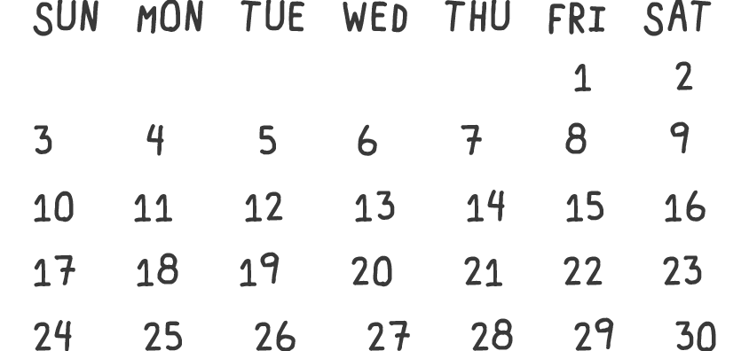z

**YOUTH GROUP: HIGH SCHOOL [SUN.] +**

**MIDDLE SCHOOL [WED.]**

We gather to read, pray, and spend time together. Bring a Bible and a friend!

**PARENT EQUIPPING MEETING**

For parents of high school and middle school students who are looking either to get some encouragement, gain some wisdom, or give some wisdom to others.

**TURKEY BOWL**

Come play some good ol’ fashioned flag football on Thanksgiving morning! 8:30-10AM

**FRIDAY NIGHT BASKETBALL**

7-9PM

**Sun + Wed**

**5**

**23**

**Fri**

**Sun + Wed**

**2**

**Fri**

**YOUTH GROUP: HIGH SCHOOL [SUN.] +**

**MIDDLE SCHOOL [WED.]**

We gather to read, pray, and spend time together. Bring a Bible and a friend!

**TIME TO DECORATE!**

Join us as we decorate the church and the youth room for Christmas! 9AM-12PM

**FRIDAY NIGHT BASKETBALL**

7-9PM

**Sun + Wed**

**6-8th**

**Fri**

**Sun + Wed**

**16**

**Fri**

**YOUTH GROUP: HIGH SCHOOL [SUN.] +**

**MIDDLE SCHOOL [WED.]**

We gather to read, pray, and spend time together. Bring a Bible and a friend!

**FALL WORK RETREAT**

We will travel to Timberlee in East Troy, WI to serve the camp to beatify the campground for the upcoming ministry year. This event is for HS and MS students.

**FRIDAY NIGHT BASKETBALL**

7-9PM

**YOUTH GROUP: HIGH SCHOOL [SUN.] +**

**MIDDLE SCHOOL [WED.]**

High school youth group meets on Sunday evenings from 6-8PM. Middle school youth group meets on Wednesday evenings from 6:30-8PM. We gather to read, pray, and spend time together. Bring your Bible and a friend!

**CORN MAZE!**

Corn maze, bonfire, time on the bus with friends… Join us for this fun fall event to build community. Bring warm clothes, shoes to get dirty, and $20. This is for HS and MS students. Register on our church center app!

**FRIDAY NIGHT BASKETBALL**

Bring your shoes, and a water bottle! Every Friday night from 7-9PM!

**Follow us on Instagram!**

**@thegrovedg**

**fbcdg.org/youth-group-downers-grove/**

**HERE**